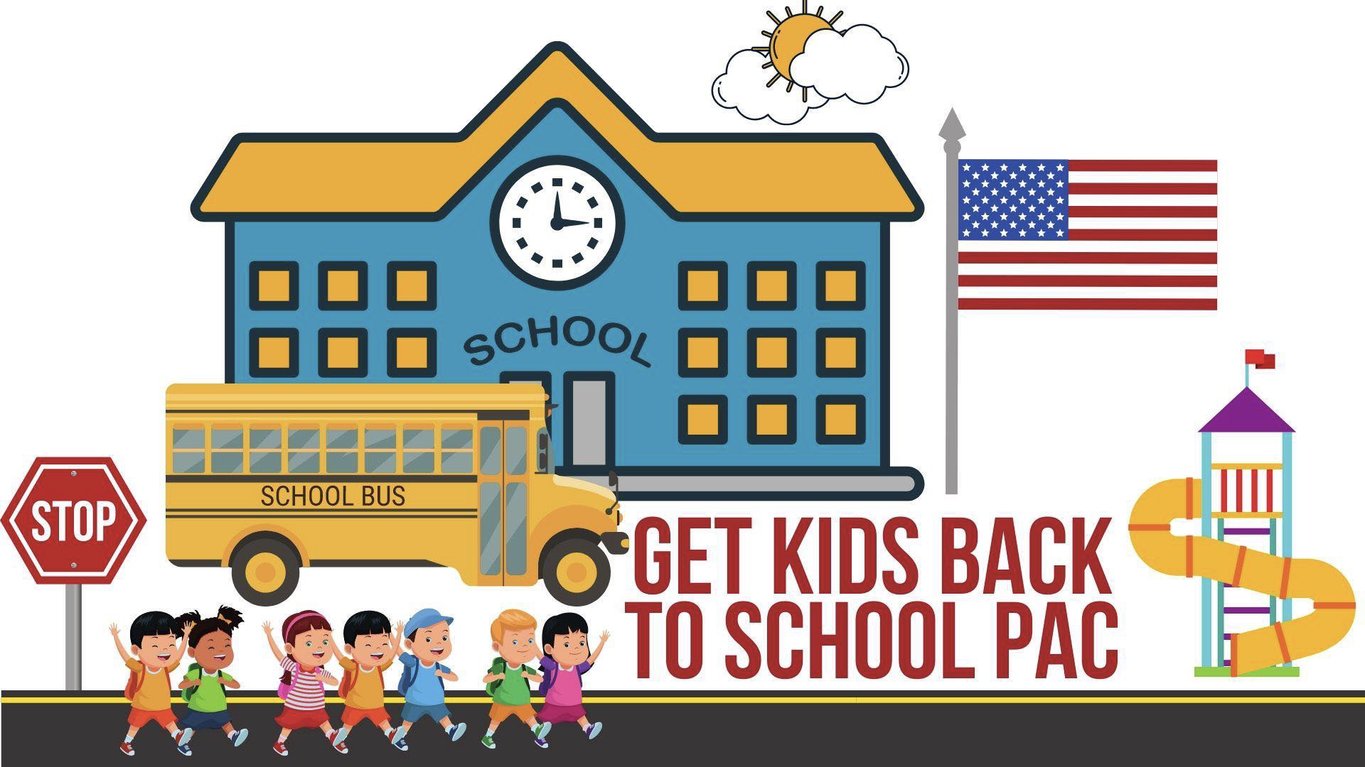

FOR IMMEDIATE RELEASE CONTACT
June 28, 2022 Matthew J. Wilk, Director
(734) 751-0328
getkidsbacktoschoolmi@gmail.com

NEW MICHIGAN EDUCATION PAC ENDORSES
SECOND ROUND OF LOCAL SCHOOL BOARD CANDIDATES

June 28, 2022 (Northville, MI) – Get Kids Back to School PAC has made their second round of endorsements for local school board elections, throughout the state of Michigan.

Lockdowns, mask mandates, forced or coerced vaccines and online learning imposed by school boards and administrations have forced tens of thousands of parents nationwide to enter the political arena, and Michigan is leading the charge. These parents have decided to get organized and push to replace incumbent school board members who called for these disastrous policies.

Matthew J. Wilk, director of Get Kids Back to School PAC noted, “This group of educational champions has been on the front lines fighting for parental involvement in schools. They will be tireless advocates for transparency, a return to basics, and ultimately, an improvement in the their local schools. They have our full and complete endorsement.”

The second round of endorsements include:

Andrew Augustine | Northville | https://getkidsbacktoschoolmi.org/candidate/drew-augustine/
Kathleen Schafer | Northville | https://getkidsbacktoschoolmi.org/candidate/kathleen-schafer/
Scott Morrell | Northville | https://getkidsbacktoschoolmi.org/candidate/scott-morrell/
Lew Miles | Chippewa Valley | http://www.electlewmiles.com
Sheryl Picard | Plymouth Canton | https://getkidsbacktoschoolmi.org/candidate/sheryl-picard/
Carol Beth Litkouhi | Rochester | carolbethforourkids.com
Chris Hollman | Novi | https://chrishollman.com/
Glenn Gogoleski | Hartland | www.glenngogoleski.com

More endorsements will be made at a later date.

Get Kids Back to School PAC, formed in 2021, is an independent expenditure-only committee dedicated to supporting candidates for local school board races who support the full return of students to school without mandates or restrictions.

Learn more at www.getkidsbacktoschoolmi.org.
###

